Microsoft Windows [Version 10.0.18362.535]

- 2019 Microsoft Corporation. All rights reserved. C:\Users\EXAM>cd\
C:\>cd snort C:\Snort>cd bin C:\Snort\bin>snort -V

,,_ -*> Snort! <*-

o" )~ Version 2.9.15-WIN32 GRE (Build 7)

- By Martin Roesch & The Snort Team: http://www.snort.org/contact#team Copyright (C) 2014-2019 Cisco and/or its affiliates. All rights reserved. Copyright (C) 1998-2013 Sourcefire, Inc., et al.
Using PCRE version: 8.10 2010-06-25

Using ZLIB version: 1.2.3

C:\Snort\bin>snort -W

,,_ -*> Snort! <*-

o" )~ Version 2.9.15-WIN32 GRE (Build 7)

- By Martin Roesch & The Snort Team: http://www.snort.org/contact#team Copyright (C) 2014-2019 Cisco and/or its affiliates. All rights reserved. Copyright (C) 1998-2013 Sourcefire, Inc., et al.
Using PCRE version: 8.10 2010-06-25

Using ZLIB version: 1.2.3

Index Physical Address IP Address Device Name Description

----- ---------------- ---------- ----------- -----------

1 24:BE:05:0F:AC:E1 0000:0000:fe80:0000:0000:0000:d882:861b

\Device\NPF_{F22D1C40-BF2A-4B59-B2BB-EB386E967426} Intel(R) 82579LM Gigabit Network Connection

C:\Snort\bin>snort -i 1 -c C:\Snort\etc\snort.conf -T Running in Test mode

--== Initializing Snort ==--

Initializing Output Plugins!

Initializing Preprocessors!

Initializing Plug-ins!

Parsing Rules file "C:\Snort\etc\snort.conf"
Detection:

Search-Method = AC-Full-Q

Split Any/Any group = enabled

Search-Method-Optimizations = enabled

Maximum pattern length = 20

Tagged Packet Limit: 256

IIS Unicode Map Filename: C:\Snort\etc\unicode.map

IIS Unicode Map Codepage: 1252

Memcap used for logging URI and Hostname: 150994944

Max Gzip Memory: 838860

Max Gzip Sessions: 2688

Gzip Compress Depth: 65535

Gzip Decompress Depth: 65535

DEFAULT SERVER CONFIG:

Server profile: All

Ports (PAF): 80 81 311 383 591 593 901 1220 1414 1741 1830 2301 2381 2809 3037 3128 3702 4343 4848 5250 6988 7000 7001 7144 7145 7510 7777 7779 8000 8008 8014 8028 8080 8085 8088 8090 8118 8123 8180 8181 8243 8280 8300 8800 8888 8899 9000 9060 9080 9090 9091 9443 9999 11371 34443 34444 41080 50002 55555

Ignore Data: No

Ignore TLS Data: No

Ignore SMTP Alerts: No

Max Command Line Length: 512

Max auth Command Line Length: 1000

Max Specific Command Line Length:

MaxClientBytes: 19600 (Default)

Ports:

22

DCE/RPC 2 Preprocessor Configuration

Global Configuration

DCE/RPC Defragmentation: Enabled

Memcap: 102400 KB

Events: co

SMB Fingerprint policy: Disabled

Server Default Configuration

Policy: WinXP

Detect ports (PAF)

SMB: 139 445

TCP: 135

UDP: 135

RPC over HTTP server: 593

RPC over HTTP proxy: None

Autodetect ports (PAF)
SMB: None

TCP: 1025-65535

UDP: 1025-65535

RPC over HTTP server: 1025-65535

RPC over HTTP proxy: None

Invalid SMB shares: C$ D$ ADMIN$

Maximum SMB command chaining: 3 commands

SMB file inspection: Disabled

DNS config:

DNS Client rdata txt Overflow Alert: ACTIVE

Obsolete DNS RR Types Alert: INACTIVE

Experimental DNS RR Types Alert: INACTIVE

Ports: 53

SSLPP config:

Encrypted packets: not inspected

Ports:
443 | 465 | 563 | 636 | 989
992 | 993 | 994 | 995 | 7801
7802 | 7900 | 7901 | 7902 | 7903
7904 | 7905 | 7906 | 7907 | 7908
7909 | 7910 | 7911 | 7912 | 7913
7914 | 7915 | 7916 | 7917 | 7918
7919 | 7920
Server side data is trusted
Maximum SSL Heartbeat length: 0
Sensitive Data preprocessor config:
Global Alert Threshold: 25
Masked Output: DISABLED
SIP config:
Max number of sessions: 40000
Max number of dialogs in a session: 4 (Default)
Status: ENABLED
Ignore media channel: DISABLED
Max URI length: 512
Max Call ID length: 80
Max Request name length: 20 (Default)
Max From length: 256 (Default)
Max To length: 256 (Default)
Max Via length: 1024 (Default)
Max Contact length: 512
Max Content length: 2048
Ports:
5060 | 5061 | 5600

Methods:

invite cancel ack bye register options refer subscribe update join info message notify benotify do qauth sprack publish service unsubscribe prack IMAP Config:

Ports: 143

POP Config:

Modbus config:

Ports:

502

DNP3 config:

Memcap: 262144

Check Link-Layer CRCs: ENABLED

Ports:

20000

Reputation config:

+ | ------------------- |  | [Rule Port Counts]---------------------------------------
| |  | tcp | udp |  | icmp | ip
| | src | 4084 | 24 |  | 0 | 0
| | dst | 7669 | 89 |  | 0 | 0
| | any | 833 |  | 7 | 4 | 0
| | nc | 453 | 0 |  | 0 | 0
| | s+d | 3 | 2 |  | 0 | 0
+ | ----------------------------------------------------------------------------
|
[ Port Based Pattern Matching Memory ]
+- [ Aho-Corasick Summary ] -------------------------------------
| Storage Format |  |  |  | : Full-Q
| Finite Automaton |  |  |  | : DFA
| Alphabet Size |  |  |  | : 256 Chars
| Sizeof State |  |  | : Variable (1,2,4 bytes)
| Instances |  |  | : 309

- 1 byte states : 293

- 2 byte states : 14

- 4 byte states : 2

| Characters | : 262242
| States | : 204489
| Transitions | : 34964857
| State Density | : 66.8%
| Patterns | : 12444
| Match States | : 13080
| Memory (MB) | : 173.38
| Patterns | : 1.07

| Match Lists : 1.81

| DFA

- 1 byte states : 1.84

- 2 byte states : 26.61

- 4 byte states : 141.74

+----------------------------------------------------------------

- Number of patterns truncated to 20 bytes: 682 ] pcap DAQ configured to passive.

The DAQ version does not support reload.

Acquiring network traffic from "\Device\NPF_{F22D1C40-BF2A-4B59-B2BB-EB386E967426}".

 | --== Initialization Complete ==--
,,_ | -*> Snort! <*-
o" | )~ Version 2.9.15-WIN32 GRE (Build 7)

- By Martin Roesch & The Snort Team: http://www.snort.org/contact#team Copyright (C) 2014-2019 Cisco and/or its affiliates. All rights reserved. Copyright (C) 1998-2013 Sourcefire, Inc., et al.
Using PCRE version: 8.10 2010-06-25

Using ZLIB version: 1.2.3

Rules Engine: SF_SNORT_DETECTION_ENGINE Version 3.1 <Build 1>

Preprocessor Object: SF_SSLPP Version 1.1 <Build 4>

Preprocessor Object: SF_SSH Version 1.1 <Build 3>

Preprocessor Object: SF_SMTP Version 1.1 <Build 9>

C:\Snort\bin>snort -i 1 -c C:\Snort\etc\snort.conf -A console

Running in IDS mode

--== Initializing Snort ==--

Initializing Output Plugins!

Initializing Preprocessors!

Initializing Plug-ins!

Parsing Rules file "C:\Snort\etc\snort.conf"

PortVar 'HTTP_PORTS' defined : [ 80:81 311 383 591 593 901 1220 1414 1741 1830 2301 2381 2809 3037 3128 3702 4343 4848 5250 6988 7000:7001 7144:7145 7510 7777 7779 8000 8008 8014 8028 8080 8085 8088 8090 8118 8123 8180:8181 8243 8280 8300 8800 8888 8899 9000 9060 9080 9090:9091 9443 9999 11371 34443:34444 41080 50002 55555 ]

Server Default Configuration

Policy: WinXP

Detect ports (PAF)

SMB: 139 445
TCP: 135

UDP: 135

RPC over HTTP server: 593

RPC over HTTP proxy: None

Autodetect ports (PAF)

SMB: None

TCP: 1025-65535

UDP: 1025-65535

RPC over HTTP server: 1025-65535

RPC over HTTP proxy: None

Invalid SMB shares: C$ D$ ADMIN$

Maximum SMB command chaining: 3 commands

SMB file inspection: Disabled

DNS config:

DNS Client rdata txt Overflow Alert: ACTIVE

Obsolete DNS RR Types Alert: INACTIVE

Experimental DNS RR Types Alert: INACTIVE

Ports: 53

SSLPP config:

Encrypted packets: not inspected

Ports:
443 | 465 | 563 | 636 | 989
992 | 993 | 994 | 995 | 7801
7802 | 7900 | 7901 | 7902 | 7903
7904 | 7905 | 7906 | 7907 | 7908
7909 | 7910 | 7911 | 7912 | 7913
7914 | 7915 | 7916 | 7917 | 7918
7919 | 7920

Server side data is trusted

Maximum SSL Heartbeat length: 0

Sensitive Data preprocessor config:

Global Alert Threshold: 25

Masked Output: DISABLED

SIP config:

Max number of sessions: 40000

Max number of dialogs in a session: 4 (Default)

Status: ENABLED

Ignore media channel: DISABLED

Max URI length: 512

Max Call ID length: 80

Max Request name length: 20 (Default)

Max From length: 256 (Default)

Max To length: 256 (Default)
Max Via length: 1024 (Default)

Max Contact length: 512

Max Content length: 2048

Ports:

5060 5061 5600

Methods:

invite cancel ack bye register options refer subscribe update join info message notify benotify do qauth sprack publish service unsubscribe prack IMAP Config:

Ports: 143

IMAP Memcap: 838860

MIME Max Mem: 838860

Base64 Decoding: Enabled

Base64 Decoding Depth: Unlimited

Quoted-Printable Decoding: Enabled

Quoted-Printable Decoding Depth: Unlimited

Unix-to-Unix Decoding: Enabled

Unix-to-Unix Decoding Depth: Unlimited

Non-Encoded MIME attachment Extraction: Enabled

Non-Encoded MIME attachment Extraction Depth: Unlimited POP Config:

Ports: 110

POP Memcap: 838860

MIME Max Mem: 838860

Base64 Decoding: Enabled

Base64 Decoding Depth: Unlimited

Quoted-Printable Decoding: Enabled

Quoted-Printable Decoding Depth: Unlimited

Unix-to-Unix Decoding: Enabled

Unix-to-Unix Decoding Depth: Unlimited

Non-Encoded MIME attachment Extraction: Enabled

Non-Encoded MIME attachment Extraction Depth: Unlimited Modbus config:

Ports:

502

DNP3 config:

Memcap: 262144

Check Link-Layer CRCs: ENABLED

Ports:

+++++++++++++++++++++++++++++++++++++++++++++++++++

+ | ------------------- |  | [Rule Port Counts]---------------------------------------
| |  | tcp | udp | icmp | ip
| | src | 4084 | 24 | 0 | 0
| | dst | 7669 | 89 | 0 | 0
| | any | 834 | 7 | 5 | 0
| | nc | 454 | 0 | 1 | 0
| | s+d | 3 | 2 | 0 | 0
+ | ----------------------------------------------------------------------------
----
| States |  |  | : 204489
| Transitions |  |  | : 34964857
| State Density |  |  | : 66.8%
| Patterns |  |  | : 12444
| Match States |  |  | : 13080
| Memory (MB) |  |  | : 173.38
| | Patterns |  | : 1.07
| | Match Lists |  | : 1.81
| | DFA

- 1 byte states : 1.84

- 2 byte states : 26.61

| 4 byte states : 141.74

+----------------------------------------------------------------

[ Number of patterns truncated to 20 bytes: 682 ] pcap DAQ configured to passive.

The DAQ version does not support reload.

Acquiring network traffic from "\Device\NPF_{F22D1C40-BF2A-4B59-B2BB-EB386E967426}". Decoding Ethernet

 | --== Initialization Complete ==--
,,_ | -*> Snort! <*-
o" | )~ Version 2.9.15-WIN32 GRE (Build 7)

- By Martin Roesch & The Snort Team: http://www.snort.org/contact#team Copyright (C) 2014-2019 Cisco and/or its affiliates. All rights reserved. Copyright (C) 1998-2013 Sourcefire, Inc., et al.
Using PCRE version: 8.10 2010-06-25

Using ZLIB version: 1.2.3

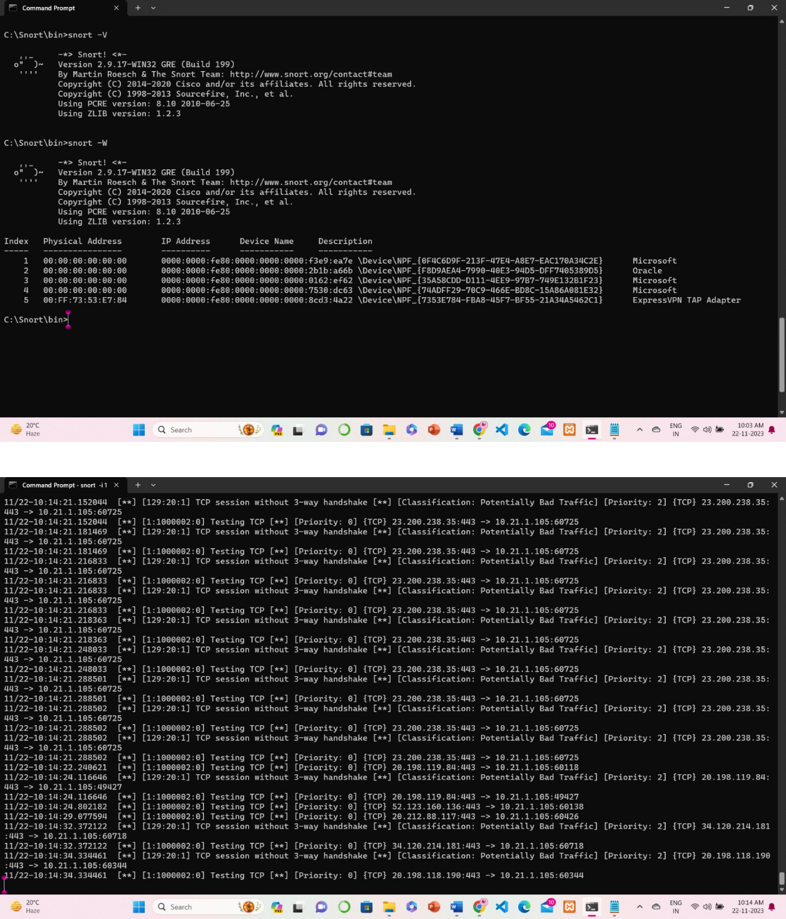
Rules Engine: SF_SNORT_DETECTION_ENGINE Version 3.1 <Build 1>

